UID EXPERIMENT-5b
NAME: PERIYA NAYAGAM M ROLL NO.:240701382
Title:
Simulation of UI Design Life Cycle using RAD Model in OpenProj
AIM:
To simulate the life cycle stages of UI design using the RAD (Rapid Application Development) model and to plan and manage the project using OpenProj.
TOOLS USED:
- OpenProj
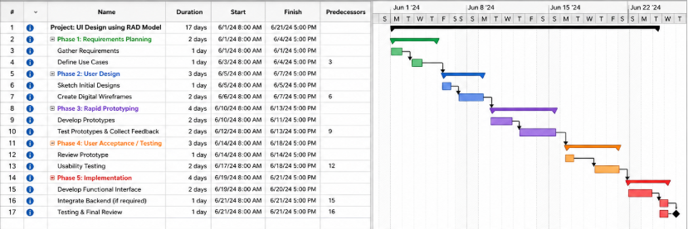
PROCEDURE:
Step 1: Requirements Planning
- Identify system requirements such as Login and Register features
- Define use cases for user interaction
- Create tasks like:
  - Gather Requirements
  - Define Use Cases
- Assign duration and dependencies in OpenProj
Step 2: User Design
- Create rough sketches of UI screens
- Design wireframes for:
  - Login Screen
  - Register Screen
- Add tasks in OpenProj:
  - Sketch Initial Designs
  - Create Wireframes
Step 3: Rapid Prototyping
- Develop interactive prototypes based on wireframes
- Test prototypes with users
- Collect feedback and refine design
- Add tasks:
  - Develop Prototype
  - Test Prototype
Step 4: User Acceptance / Testing
- Review the prototype with users
- Conduct usability testing
- Record feedback and issues
- Add tasks:
  - Review Prototype
  - Usability Testing
Step 5: Implementation
- Develop the final user interface
- Integrate backend if required
- Perform final testing
- Add tasks:
  - Develop Functional Interface
  - Integration
  - Final Testing

RESULT:
The UI design life cycle using the RAD model was successfully simulated using OpenProj. All phases, including Requirements Planning, User Design, Rapid Prototyping, Testing, and Implementation, were properly scheduled with tasks, durations, and dependencies. The Gantt chart clearly represented the project timeline, ensuring effective planning and execution.

